**Follow the QR Code for Directions**

**Priority House**

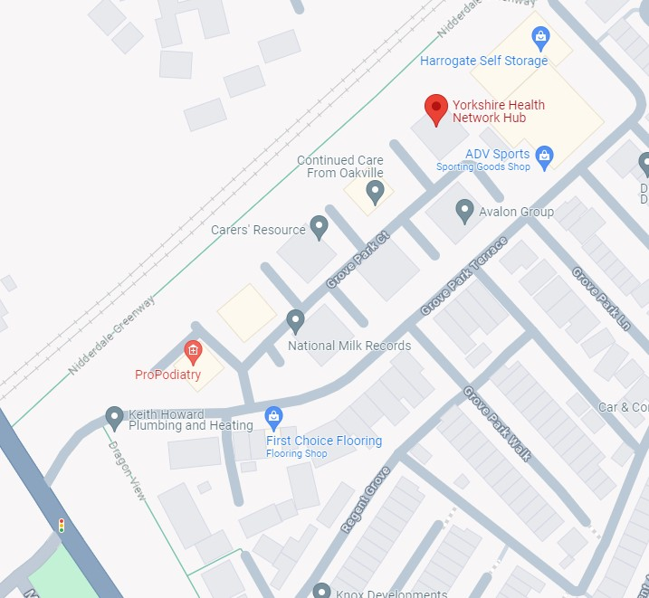

You may be offered an appointment with Enhanced Access or for Travel vaccinations but where is this?

Enhanced access is spread across 3 sites in the district, and you will be informed which site your appointment is at, this can be:

* Priority House
* Beech House Surgery
* Leon Smallwood Unit, Ripon Hospital.

**Follow the QR Code for Directions**

**Leon Smallwood Unit**

**Follow the QR Code for Directions**

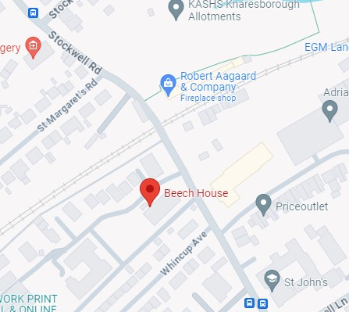

**Beech House Surgery**