BEECH HOUSE SURGERY
Newsletter
December 2019

A message from Dr Marfell on behalf of the Partners and Practice Staff to all Our Patients:
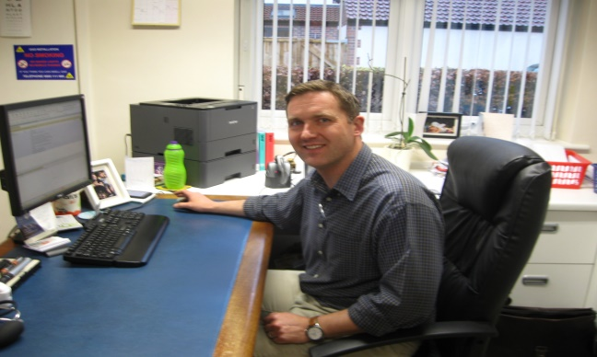

From our practice to your home, we wish you a Merry Christmas and an exceptionally healthy New Year. It may be cold outside, but winter needn't be the unhealthiest time of year for you and your family. Here are five ways to make sure that, even when your body is telling you to hibernate, you can keep healthy and fit, no matter what the weather's like.
1) Banish winter tiredness - Many people feel tired and sluggish during winter. This is due to the lack of sunlight, which disrupts our sleep and waking cycles. Try these tips:
•get outdoors in natural daylight as much as possible
•get a good night's sleep – go to bed and wake up at the same time every day
•destress with exercise or meditation – stress has been shown to make you feel tired
2) Eat more fruit and veg - When it's cold and dark outside, it can be tempting to fill up on unhealthy comfort food. However, it's important to ensure you still have a healthy diet and include five portions of fruit and veg a day.
If you find yourself craving a sugary treat, try a juicy clementine or satsuma instead.
Winter vegetables such as carrots, parsnips, swede and turnips can be roasted, mashed or made into soup for a comforting winter meal for the whole family. Explore varieties of fruit and veg that you may not normally eat.
3) Drink more milk - You are more likely to get a cold in winter, so make sure your immune system is in tip-top condition. Milk and dairy products such as cheese, yoghurt and fromage frais are great sources of:
•protein
•vitamins A and B12
•calcium, which helps keep our bones strong
Choose semi-skimmed, 1% or skimmed milk – rather than full-fat – and low-fat plain yoghurts.
4) Try new activities for the whole family - Don't use the cold winter months as an excuse to stay in and lounge around. Instead, get out with the whole family to try out a new activity –maybe ice skating, or taking a bracing winter walk on the beach or through the park. Regular exercise helps control your weight, boost your immune system, and is a good way to break the tension that can build if the family is constantly cooped up inside the house.
5) Have a hearty breakfast - Winter is the perfect season for porridge. Eating a warm bowlful on a cold morning isn't just a delicious way to start your day, it also helps boost your intake of starchy foods and fibre.
These foods give you energy and help you feel fuller for longer, stopping the temptation to snack mid-morning. Oats also contain lots of vital vitamins and minerals. Make your porridge with semi-skimmed, 1% or skimmed milk, or water, and don't add sugar or salt. Add a sliced banana, berries or other fruit for extra flavour and to help you hit your 5 A Day target.
STAFF NEWS
Congratulations to Toni Kinder, a member of the Reception team who had a little boy safely on 6th Nov - 7lb 14 oz Albie...mum & baby both doing amazingly well.
We welcome our new FY2 Dr Rachel Newby and hope she enjoys her time at Beech House.
FLU CLINIC
The next Flu clinic for the Under 65s will be held on Saturday 7 December, please book your appointment at Reception.
PHYSIOTHERAPY
If you would like help and advice on exercises then go to the following website: harrogatehealthhub.co.uk
EVENTS
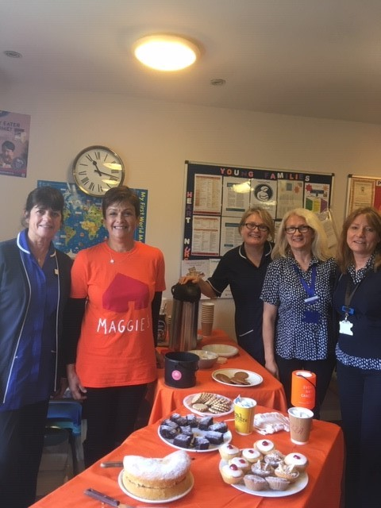
Beech House are pleased to support and raise awareness for Maggie`s Yorkshire.
A coffee morning was held at Beech House surgery on Saturday 12th October during the flu clinic to raise much needed funds. Sarah Blood from the Patient Participation group along with support from the nursing and reception staff were successful in raising £160 from donations for freshly baked cakes and drinks.
Many thanks to all those patients who donated so generously.

PATIENT PARTICIPATION GROUP (PPG)
The PPG held it’s AGM on November and we welcomed to new members to our group; Fiona Green and Sue Kitching.
We wish all patients at Beech House a very Happy Christmas and a healthy New Year.
The PPG can be contacted through - beechhousesurgery.nhs.net – Please mark your email with the heading “PPG”

FUTURE CONTENT - Please let us know of any particular topic that you would like to see featured in our next Newsletter.

