

Newsletter – Autumn 2023 Issue

**STAFF NEWS**

**LEAVERS:**

We haven't had any leavers since the Summer Newsletter

**STARTERS:**

Again, we have not had any new starters since the last newsletter. The following team members joined us recently and have fast become established as part of our team 😊

* Dr Tom Fowler-Roughton – GP Registrar
* Dr Emily Evans – Foundation Year 2 Doctor
* Nikki Tremble – Dispensary Manager
* Jane Higgison – Dispenser
* Jo Banks – Practice Nurse

**PRIMARY CARE NETWORK (PCN) STAFF:**

These are staff who work across the practices in Knaresborough and Rural PCN

In addition to Jo our current FCP (First Contact Physiotherapist) we have now got an additional FCP Jenny, welcome!

Sarah Eastland joined the PCN as Digital Transformation Manager working across the 6 practices in Knaresborough and Rural PCN. She is working on digital projects such as policies and protocol, websites, etc.

YHN (Yorkshire Health Network) our GP federation have been working at Beech House on a Saturday for some time now, offering GP and Nurse/HCA appointments outside of normal practice hours. This service will continue and going forwards they will also be here on a Sunday. Appointments are booked through reception and are available for all patients in the area and not just limited to Beech House patients.

**SERVICES:**

**FLU AND COVID BOOSTERS:**

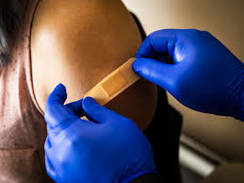

The Flu campaign for 23/24 is here! We are due to receive our vaccines on the 28th September 2023 and we have Saturday Flu Clinics scheduled for the 30th September 7th October and 14th October.

There are appointments available during the week for patients who cannot attend the Saturday clinics.

We will be offering eligible patients COVID boosters at these clinics… if you have booked an appointment for a flu vaccination and would like a COVID booster as well then you do not need to book a separate appointment. If you would like either a flu or COVID booster on its own this is fine – just let your vaccinator know when you attend for your appointment.

**CHAIN LANE PHLEBOTOMY SERVICE:**

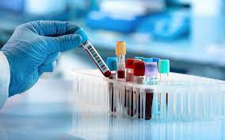

The new bloods service at Chain Lane Hub is going well – this service is run by Harrogate and District NHS Foundation Trust.

The service is open from 07:30-11:00 Monday to Friday. Please note that you MUST have a printed ICE form and take this with you as they cannot take blood without.

Ample free car-parking, wheelchair friendly, seated waiting area, experienced Harrogate Hospital phlebotomy staff

**ASK A MIDWIFE:**

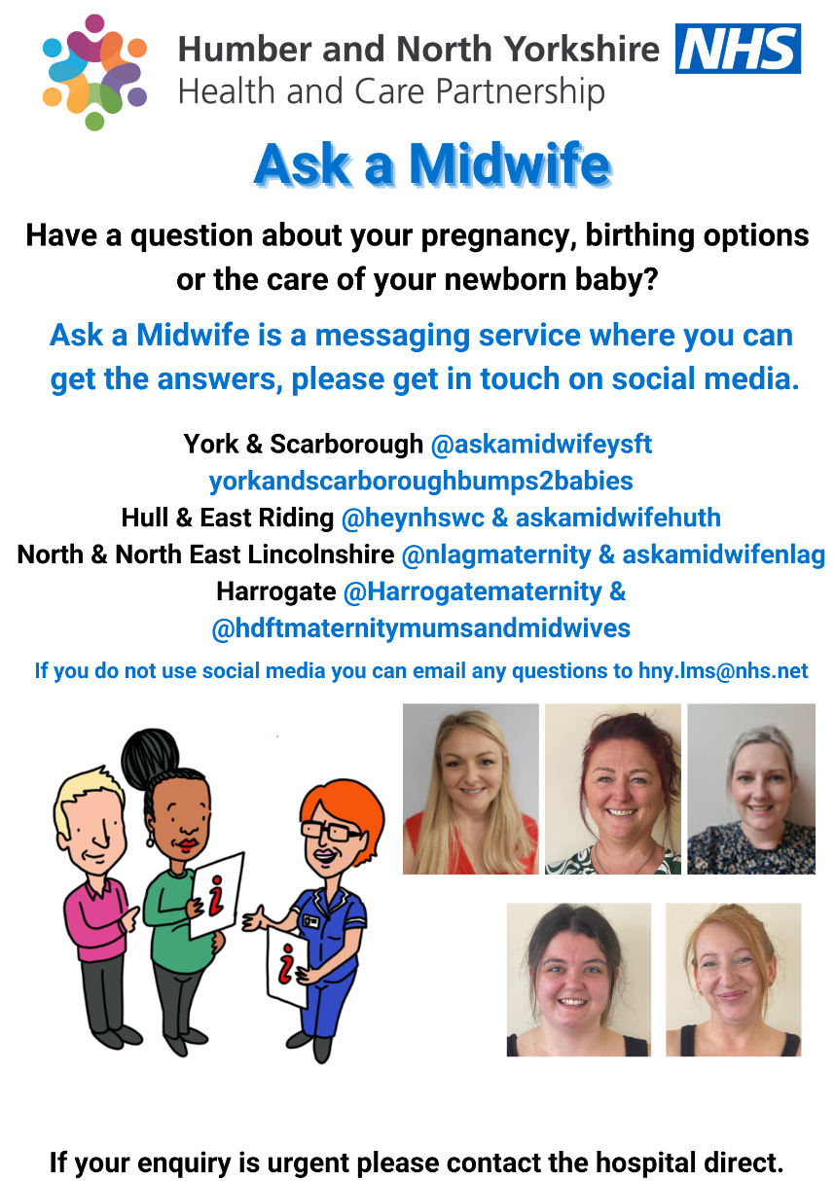

**TALKING THERAPIES:**

Talking Therapies is a national NHS programme designed to increase the availability of talking therapy treatments recommended by the National Institute for Health and Clinical Excellence (NICE).

Significant events like bereavement, unemployment, relationship breakdown, traumatic events or even stress at work can lead to difficulties requiring help and support. Problems with low mood and anxiety can develop and make it difficult for us to cope with life's daily demands. Patients can self-refer by completing an online referral form:

[www.northyorkshiretalkingtherapies.co.uk](http://www.northyorkshiretalkingtherapies.co.uk)

Assessments are undertaken over the phone and you will be advised about the right help within the service. Where Talking Therapies are not the most suitable service, they will signpost to alternatives where available.

We have a Talking Therapies Practitioner working in the practice every Monday.

**DEMENTIA:**

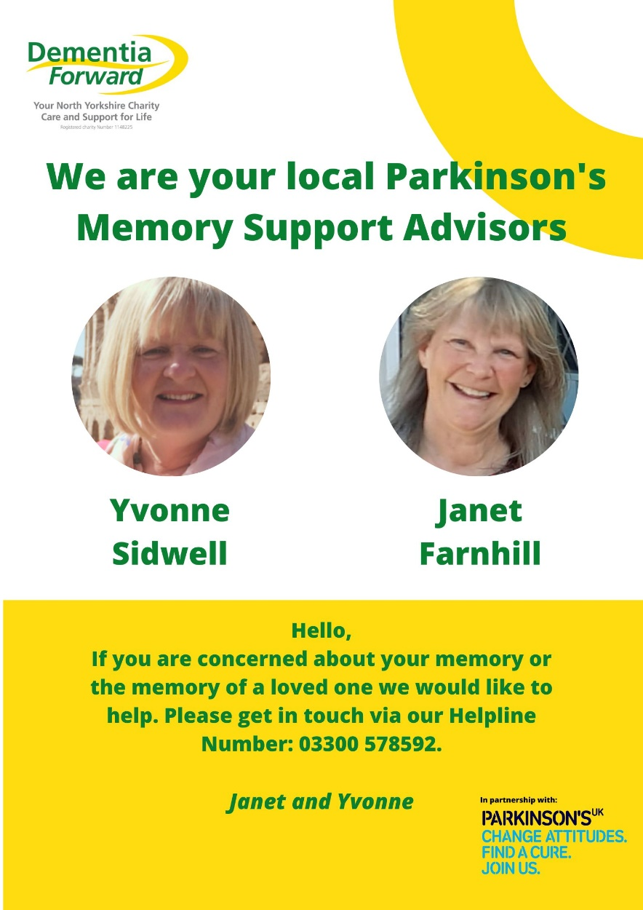

**PATIENT PARTICIPATION GROUP (PPG)**

Who are we? We are a group of patients who wish to support and promote all that the Practice does. We have approximately four meetings a year including our AGM. Any patient of the Practice is welcome to attend the AGM which is held in September. We publish/advertise the date approximately a month in advance.

The PPG can be contacted through – beechhousesurgery@nhs.net – Please mark your email with the heading “PPG”

**FUTURE CONTENT:**

Please let us know of any particular topic that you would like to see featured in our next Newsletter.

**AND FINALLY…..**

New data published by NHS England shows what people think about their doctor's surgery. The latest GP Patient Survey produced by Ipsos on behalf of NHS England asked people across the country what they think about many aspects of their care, including the appointment booking process.

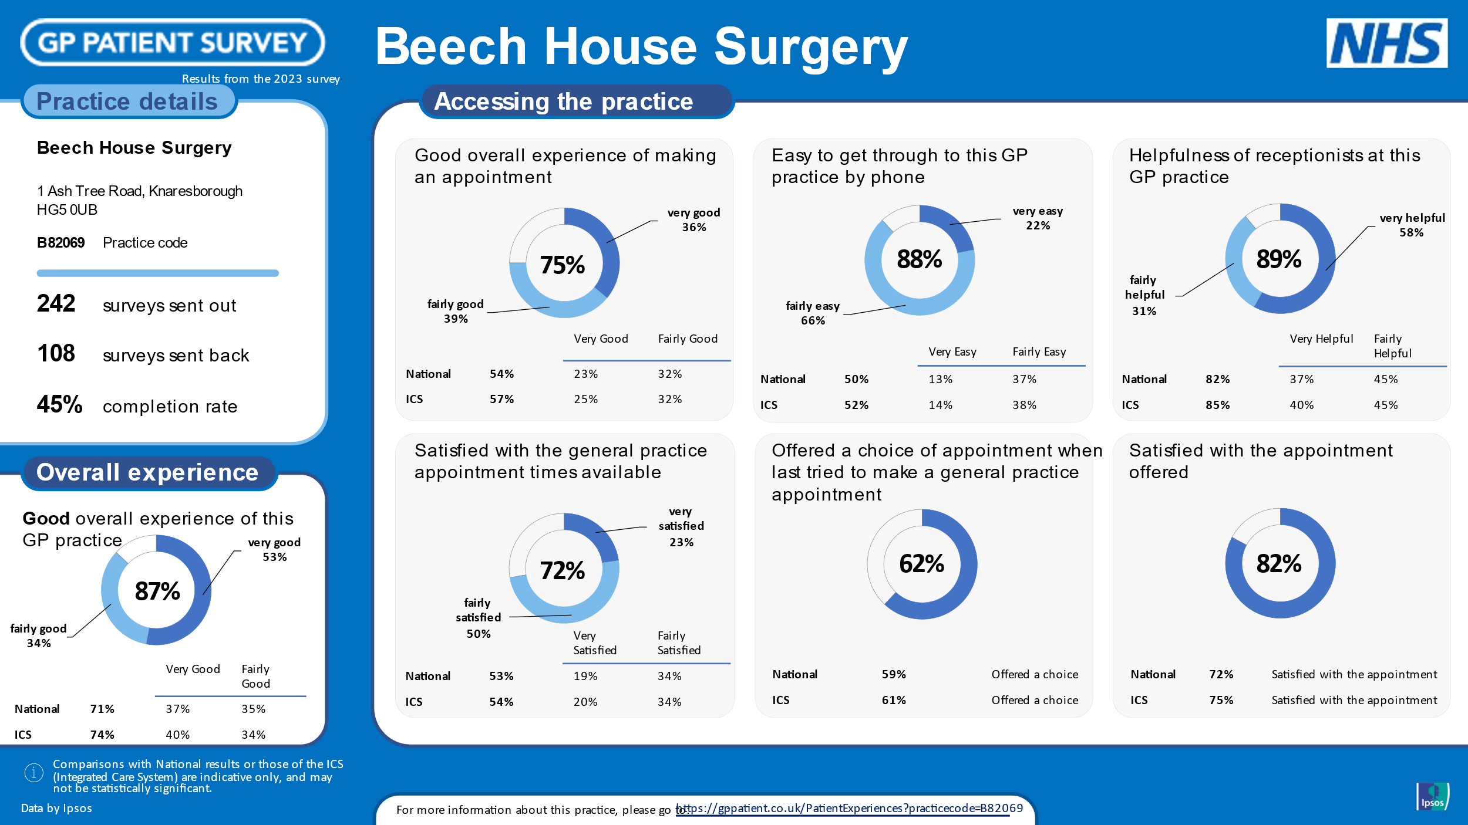

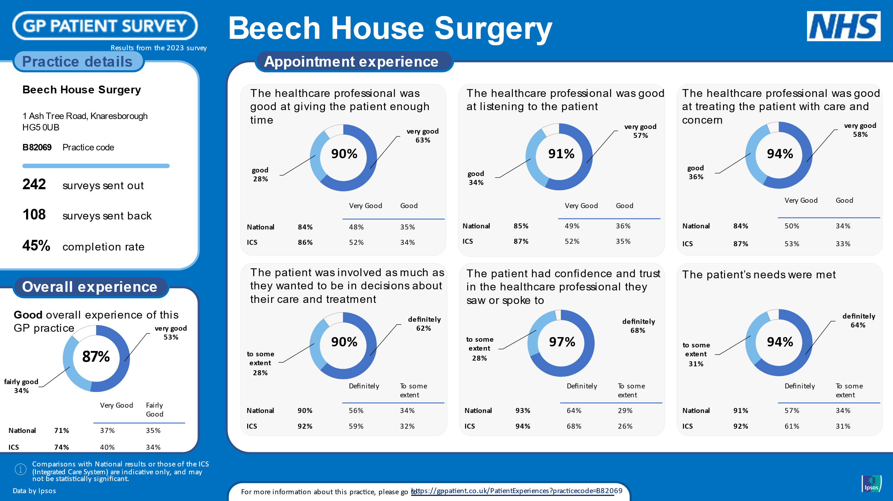

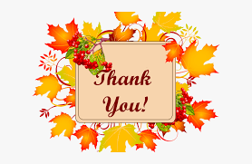

**We would like to say a big thank you to everyone who participated in the survey – we strive to provide the best possible service and care for our patients and it is lovely to see positive results!**