

Newsletter – Winter 2024 Issue

**STAFF NEWS**

**LEAVERS:**

The following team members are leaving the practice:

* Dr Tom Fowler-Roughton – Tom has passed his final GP examinations, congratulations! We wish him well as he moves to a new role in general practice in the New Year
* Dr Vincent De Martini-Griffin, Foundation Year 2 Doctor – Vinnie is moving on in December 2024 to his next placement at Harrogate Hospital
* Helen Hardwick, Senior Medical Receptionist – Helen retires at the end of this month, however, will be staying "on the books" as a Bank Receptionist which is great as she is a fantastic member of the team

We will them all the best in their future endeavours.

**STARTERS:**

The following team members have recently joined us/are joining us:

* Dr Sharon Babu – Foundation Year 2 Doctor
* TBC – At the time of writing, we don’t know who our new GP Registrar will be
* Rebecca Cooper-Kay – Rebecca has been with us for a while but has recently been promoted to Senior Receptionist
* Emma Powell – Medical Receptionist

Welcome to the Beech House team!

**PRIMARY CARE NETWORK (PCN) STAFF:**

These are staff who work across the practices in Knaresborough and Rural PCN as part of the additional roles (ARRS) scheme.

YHN (Yorkshire Health Network) our GP federation have been working at Beech House on a Saturday and Sunday for some time now, offering GP and Nurse/HCA appointments outside of normal practice hours.

Appointments are booked through reception and are available for all patients in the area (booked through their own GP Practice) and are not just limited to Beech House patients.

Just to remind everyone we have the following members of staff working in the practice (in no particular order) alongside our employed practice staff:

* Justine De Taure – Care Coordinator
* Christine Allison and Heather Brock – Social Prescribers
* Richard Green – Health and Wellbeing Coach
* Ron Wilkinson – ACP Paramedic
* Chantal Hoyle – Mental Health Practitioner
* Jo Ball and Jenny Rees – First Contact Physiotherapist
* Samee Ahmed and TBC (vacant post) – Clinical Pharmacists
* Martina Halstead and Dhaya Katnoria – Pharmacist Technicians
* The PACT Team (Pro Active Care Team)

**SERVICES:**

**FLU AND COVID BOOSTERS:**

We are well under way vaccinating patients as part of the Flu and Covid vaccination campaign for 24/25. We have a small number of vaccines still available – If you are eligible and have not been vaccinated this Autumn please contact us to check availability.

**RSV VACCINATIONS:**

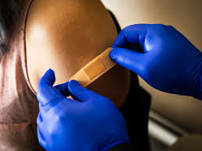

The RSV vaccine helps protect against respiratory syncytial virus (RSV), a common virus that can make babies and older adults seriously ill. It's recommended during pregnancy and for adults aged 75 to 79. The RSV vaccine helps protect against respiratory syncytial virus (RSV).

RSV is a common cause of coughs and colds. Most people get it several times during their life.It usually gets better by itself, but in some people (especially babies and older adults) it can cause illnesses such as:

* pneumonia (a lung infection)
* bronchiolitis (a chest infection that affects babies)

These illnesses can cause serious breathing problems. They may need to be treated in hospital and can be life-threatening. Getting RSV can also make your symptoms worse if you have a lung condition, such as chronic obstructive pulmonary disorder (COPD).

The RSV vaccine is recommended if:

* you're pregnant – the vaccine is recommended during every pregnancy (from 28 weeks onwards) to help protect your baby after they're born
* you're aged 75 to 79

We have started to contact eligible patients to book in to our RSV clinics.

**HAVING TO STAY IN HOSPITAL?**

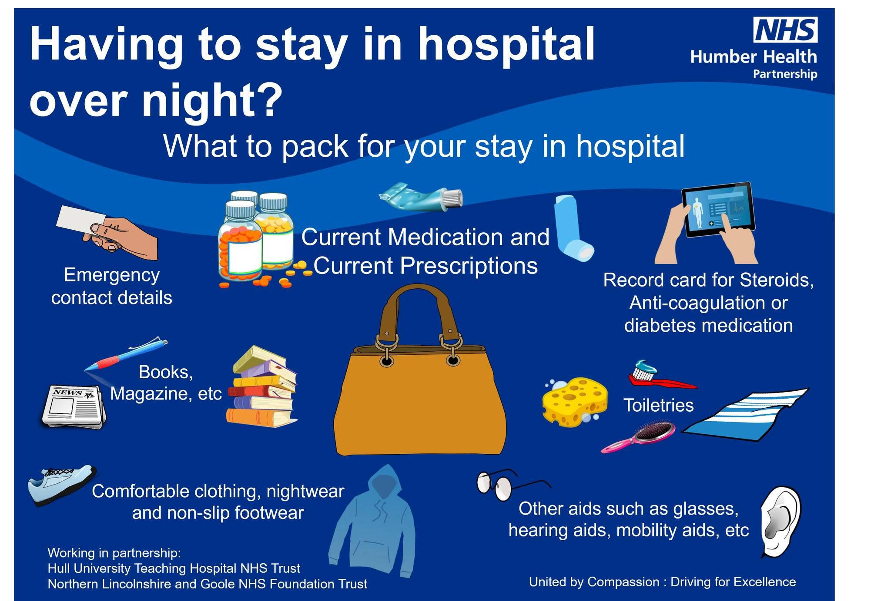

**OP COURAGE**

At the time of writing, we honour the bravery and sacrifice of our veterans and service members, especially those supported by Op COURAGE.

Remembering can be hard. If you’ve served in the UK Armed Forces, are struggling with your mental health and live in England, Op COURAGE is here to help. Op COURAGE is a mental health and wellbeing service developed by veterans, for veterans. Info at [www.nhs.uk/opcourage](http://www.nhs.uk/opcourage?fbclid=IwZXh0bgNhZW0CMTAAAR174GNCI2ItaleB_CCGSl5LbYpOaLSm47azzsjjuULe5nO6ReeoJmLcHOg_aem_HsyycQlezUMMu17AhSA-mQ)

We will remember them

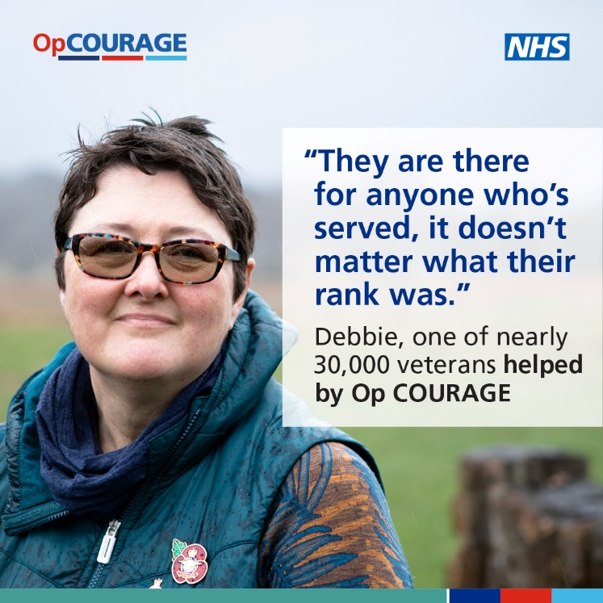

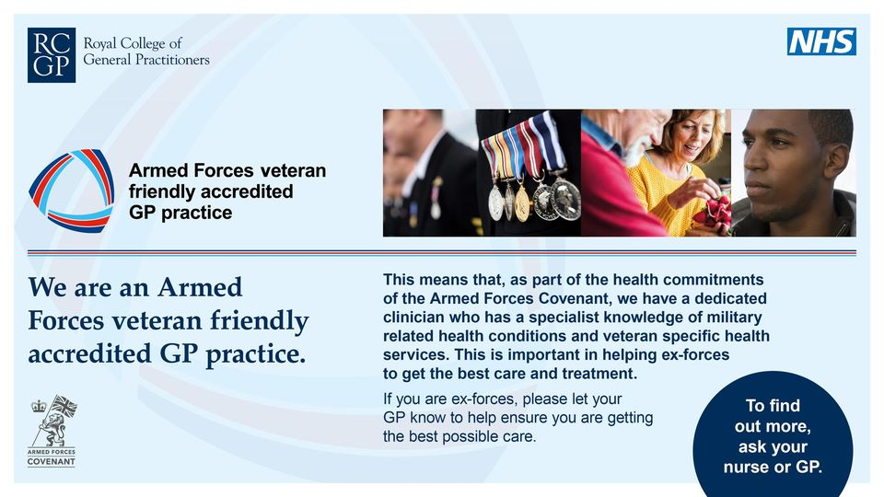

**PATIENT PARTICIPATION GROUP (PPG)**

Who are we? We are a group of patients who wish to support and promote all that the Practice does. We have approximately four meetings a year including our AGM. Any patient of the Practice is welcome to attend the AGM which is held annually. We publish/advertise the date approximately a month in advance.

The PPG can be contacted through – beechhousesurgery@nhs.net – Please mark your email with the heading “PPG”

**PRACTICE STATEMENT ON COLLECTIVE ACTION:**

You may have heard that GPs across England have voted to take “Collective Action” as a response to their latest contract negotiations.  We wanted to explain what this means for our patients, and outline the steps that we, and some of the other local practices, will be taking to ensure that this is safe and appropriate.

**Are you on strike?**

 No, GPs are *not*taking strike action, and surgeries will remain open as usual. If you need your GP please contact the surgery as normal. However most GPs in England do a good deal of work which is not currently funded, or part of their core contract, and it is this that the BMA has suggested we review.

**Why is this action being taken?**

 Currently General Practice is responsible for the vast majority of the work carried out in the NHS but receives only 6% of the funding. In the last 5 years GP practices have lost funding worth over £660 million pounds – and yet we’re busier than ever – with practices seeing 14 % more patients than they were pre-Covid. This is proving increasingly difficult to sustain – 1 in 4 practices nationally have stated they are at risk of closure, and 1 in 5 have already closed or merged in the last decade.

Similarly the NHS has lost the equivalent of 1,694 full time GPs since 2015.  We are, obviously, keen to try and protect local services from the same fate.

**How do we compare locally?**

 We are every bit as busy.  Within our Primary Care Network (PCN - a group of 6 local practices) each patient attends, on average, 7.75 times a year, which exceeds even the national average.  71% of those appointments are face to face, and over 40% of these are on the same day.

The situation in this region is particularly challenging as, unlike most of the country, there is no local Urgent Treatment Centre.  Where most surgeries can easily redirect urgent same day needs without sending to A&E, we cannot.  This inevitably affects our ability to offer routine appointments with the GP of your choosing, which contributes to longer waiting times.

**What steps will we be taking?**

 The BMA has recommended 10 steps for practices to adopt in response to the call for action.  We have decided not to adopt all of these at this stage but will be implementing some of them.  When doing this we have been particularly mindful of trying to ensure that steps taken protect our patients as much as possible, and we have prioritised those we feel are important for safety.

These are:

* **Capping appointments**.  The BMA has advised practices to limit appointments to 25 per GP, per day, in keeping with recommended safe maximums determined by the European Union of GPs. Many practices within the PCN already do this, although not necessarily to this level.  Each practice within the PCN, including this one, will be reviewing patient numbers and applying a cap to ensure clinicians are not seeing an unsafe number of patients. This will vary for each practice within the PCN, and factors such of numbers of GPs, and rurality, will likely affect this.  We will not be seeing less than the recommendation, and where safe and appropriate, may see more.  On reaching the cap we will still provide advice and signposting to appropriate services, including urgent care settings. ***Please still contact the surgery if you need to be seen.***
* **Stop rationing referrals**.  Currently there are a number of restrictions in place on which patients we can refer for certain conditions.  We will no longer acknowledge these, and instead refer any patients for whom we believe it would be clinically appropriate to do so.
* **Continue to seek Advice and Guidance**. The BMA have advised that practices stop sending “Advice and Guidance” letters to hospital as an alternative to referral. We have opted not to stop these entirely as they are often helpful to our patients and can prevent unnecessary appointments.  However, where responses to this guidance clearly indicate that the patient would be better receiving care from a hospital consultant rather than out-sourcing to a GP, we will be converting to referral, and informing them of such.  We will also be resisting attempts to discharge patients for whom the hospital is continuing to request ongoing investigations.
* **Review “Commissioning gaps”**.  The BMA has advised that practices should stop any actions carried out voluntarily by practices that should instead be commissioned healthcare services.  In our region there are a significant number of these. There are, in addition, a number of services for which practices receive some funding, but which are provided at a substantial loss.  We are concerned however about the impact of stopping these services overnight – particularly for our patients in more isolated areas who may struggle to access alternative provision.  As such we intend to review these services, stopping where we feel it is possible to do so safely, and discussing with the commissioner a suitable solution for those where an alternative would need to be identified.
* **The remaining actions are unlikely to have direct impact for patients**.  These chiefly relate to data sharing agreements, software, and engagement with pilot programmes.  Practices will review where these recommendations can be sensibly adopted within the confines of our existing contract.

Again, this is not a strike. The surgery will continue to fulfil all of the requirements of our contract with the NHS for patient care.  However it is also worth noting that the changes mentioned above are not intended as a statement of short term protest, but rather long term systemic change to the way in which we work, in order to ensure General Practice remains sustainable in this community for the foreseeable future.  Without such changes, this is sadly unlikely.

**FUTURE CONTENT:**

Please let us know of any particular topic that you would like to see featured in our next Newsletter.

**AND FINALLY…..Did you know?**

Beech House Surgery can issue Foodbank Vouchers for those in need.

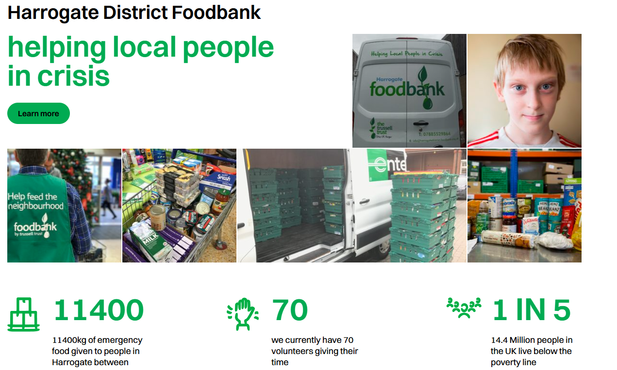

***“The foodbank was there when we really needed it, it was an absolute lifeline.”***

We don’t think anyone in our community should have to face going hungry. That’s why we provide three days’ nutritionally balanced emergency food and support to local people who are referred to us in crisis. We are part of a nationwide network of foodbanks, supported by The Trussell Trust, working to combat poverty and hunger across the UK.

For more information contact <https://harrogatedistrict.foodbank.org.uk/> or call [07885529864](tel:07885529864)

Or ask a member of our Reception Team for more information.